Model Selection: cross-validation RMSE

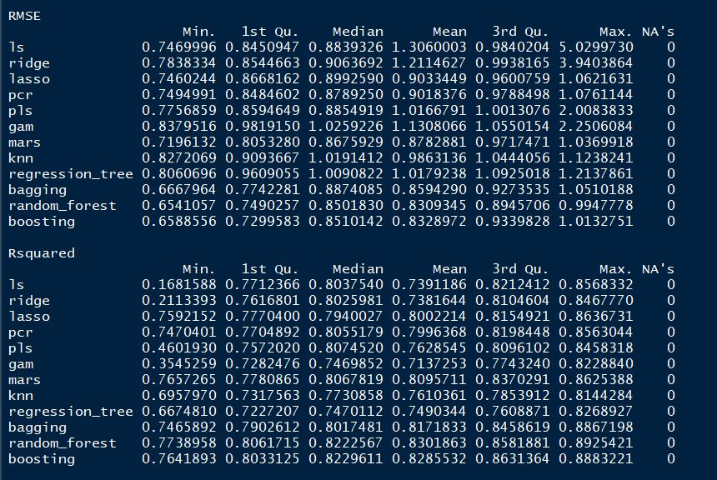

Model Validation: test MSE

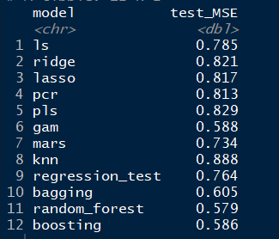

**Tuning parameters for new 5 models**

KNN:

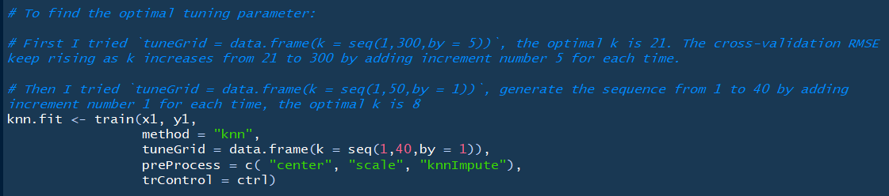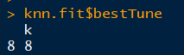

Regression Tree:



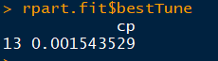

Bagging:

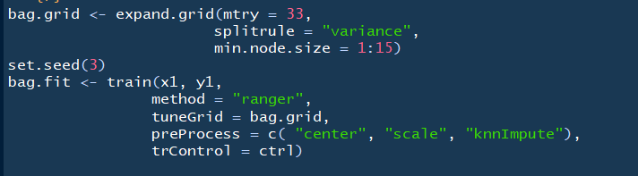

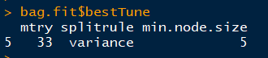

Random Forest:

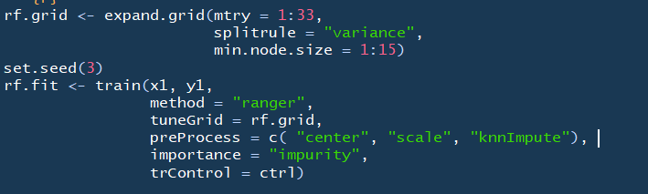



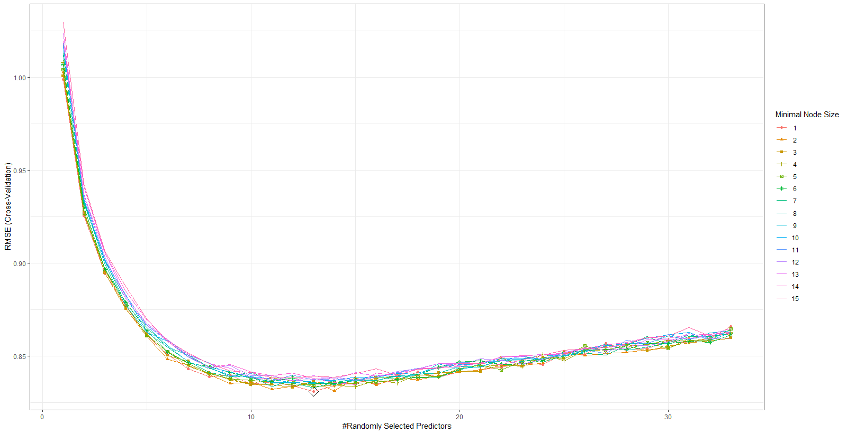

Boosting:

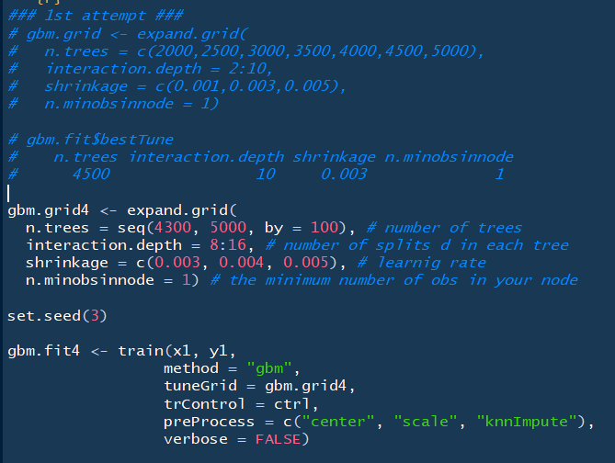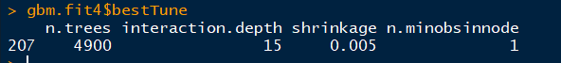

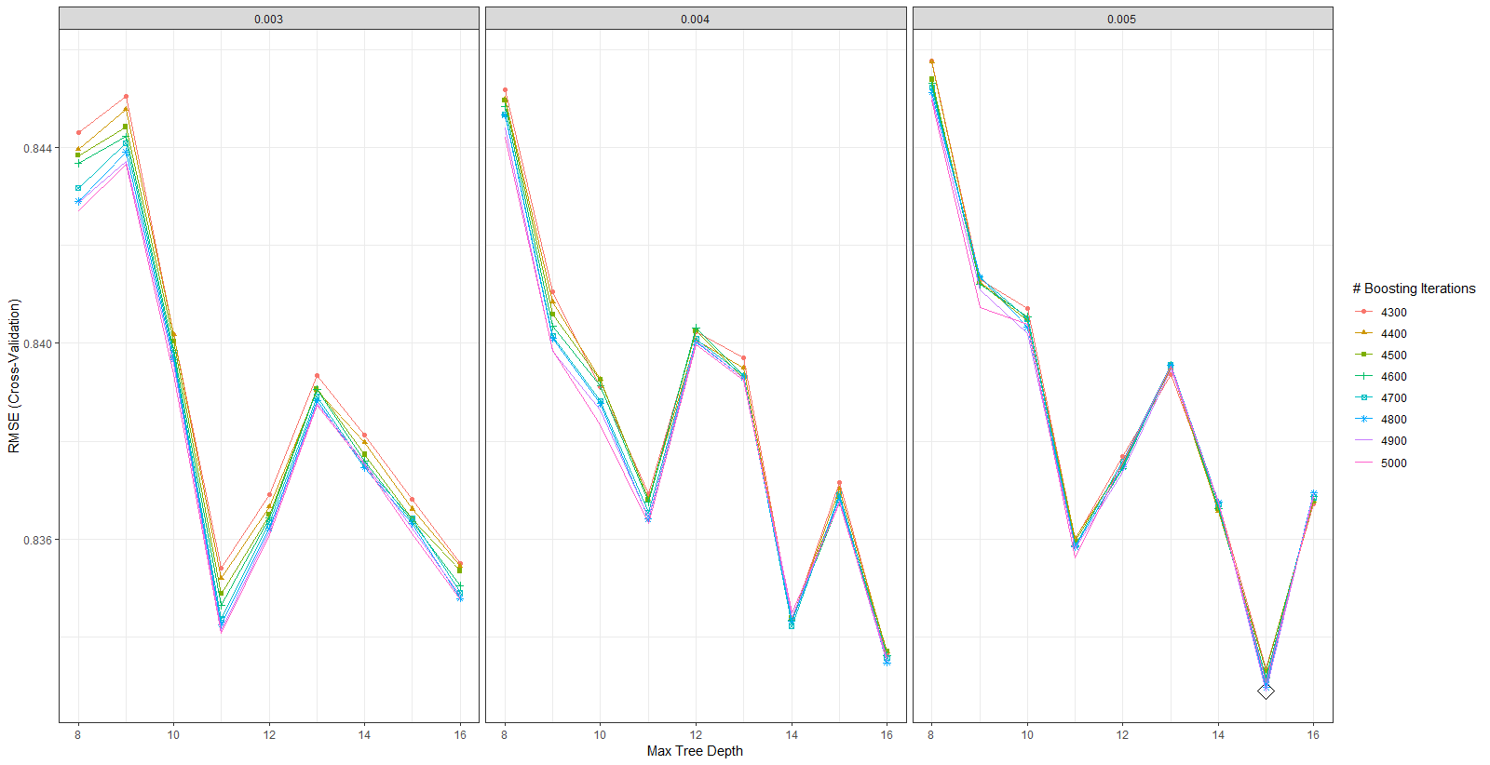

**Variable Importance: report top 3 or top 5**

Random Forest:

all_death

poverty

no_hs_diploma

Disabled_Medicare

Black

health_status

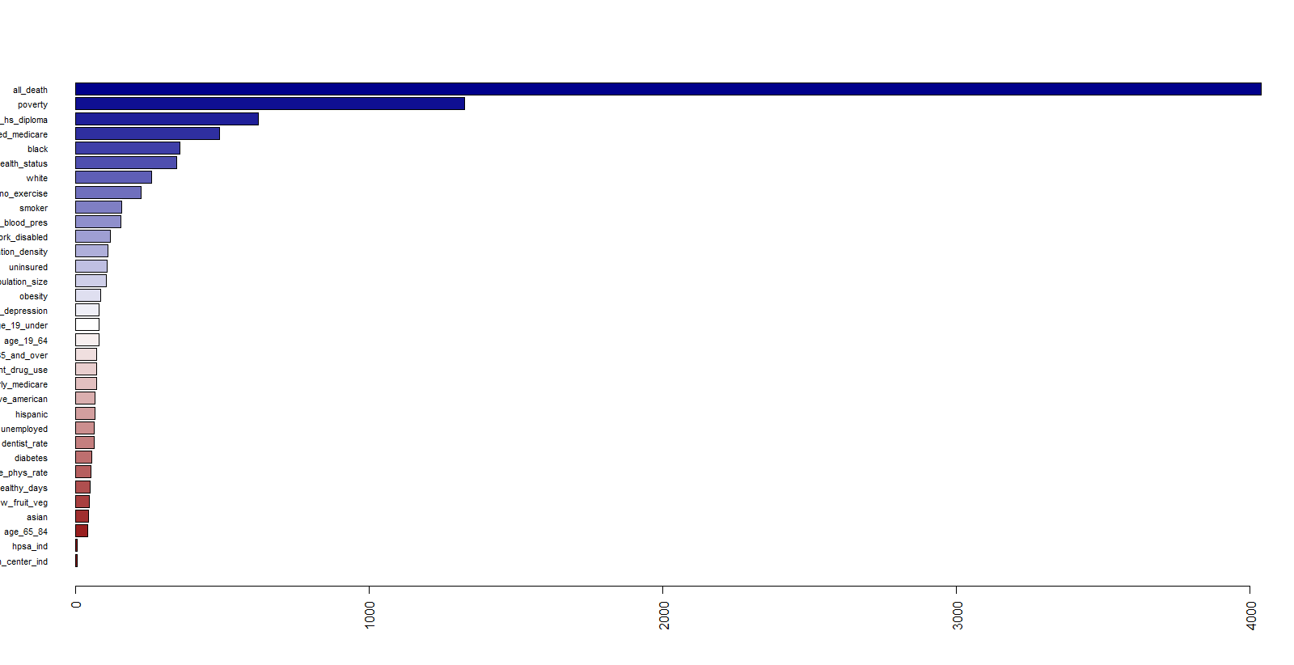

Boosting:

